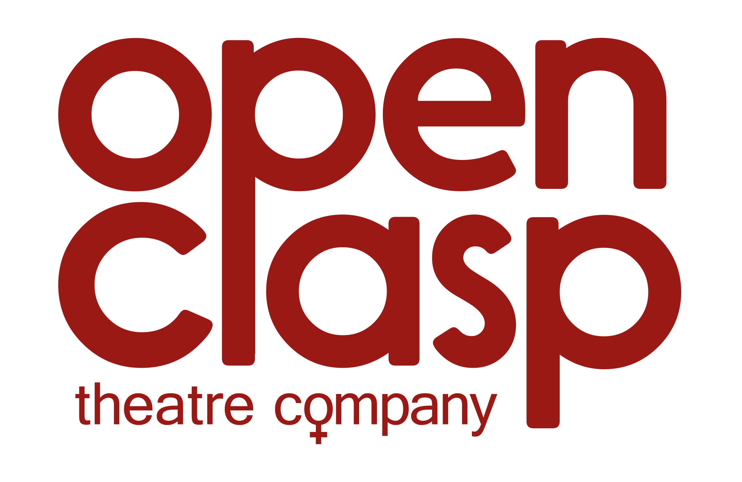

Company Development Manager

Thank you for your interest in the position of Company Development Manager at Open Clasp Theatre Company.

Please find below the application pack which contains the following documents:
How to apply, Job Summary, Job Description, Person Specification, About Open Clasp and the Application Form. Please also see www.openclasp.org.uk for further information about the company and our work.

How to apply

- Read the Job Description and Person Specification.
- Complete the application form – please note we do not accept CVs.
- The first two pages of the application form, containing your personal details and monitoring information, will be removed prior to short-listing to ensure the process is fair. Please do not add your name to any of the other sheets.
- Use the Supporting Information section on the last page of the application form to tell us how you meet the skills set out in the Person Specification.
- If you would like any further information, have any specific requirements or would like to discuss any aspect of the role in confidence, please contact our Artistic Director, Catrina McHugh on 0191 272 4063.
- Once you have completed the application form please email it to recruitment@openclasp.plus.com putting the job title in the subject box or post a hard copy to Recruitment, Open Clasp Theatre Company, The Stephenson Building, 173 Elswick Road, Newcastle upon Tyne, NE4 6SQ. Please mark your envelope “Private & Confidential”
- Applications must be received by the deadline of 12 noon on Wednesday 31st January, 2018 to be included in the recruitment process.

We look forward to receiving your application and will reply to all applications.

Interviews will be held on 13th February 2018 in Newcastle upon Tyne.

The post is open to women only (exempt under the Equality Act 2010 Schedule 9, Part 1).

Please note that, as the role will involve financial responsibility and may involve working with vulnerable adults, the successful applicant will be subject to an enhanced Disclosure and Barring Service (DBS) check.

Job Summary

The Company Development Manager will work with our Artistic Director, Creative Producer, Administrator and Board of Trustees, being responsible for income generation, development and day-to-day operation of the company.

A full induction will be given and training provided where needed. The position is offered part time and is based in our Newcastle office, Stephenson Building (West End Women and Girls Centre), Elswick. All applications will be considered on merit and in accordance with our equal opportunities policy.

Outline terms and conditions:

Job Title: Company Development Manager
Reports to: Artistic Director and Board of Trustees
Management of: Administrator
Key Objective: Day-to-day management of the organisation and responsible for the financial sustainability of the company.

Salary: NJC Scale SO2 (32 – 34) £28,485 - £30,153 pro rata
Contract: Permanent contract (subject to 6 month probationary period)
Hours: Part time – minimum of 28 hours per week. Occasional evening and weekend work will be required. We are open to Job Share and flexible working for the right candidate. Subject to funding, this role may go full time.
Location: Open Clasp’s office at West End Women and Girls Centre, Elswick, Newcastle upon Tyne.
Notice Period: 1 month, increasing to 1 week per year following 4 years’ service

Job Description

Job Purpose:
The Company Development Manager will be responsible for the day-to-day management of the organisation and the financial sustainability of the company, working with our established team to build and maximise on the company’s current success.

Key Responsibilities
- Planning, developing and implementing strategies to increase Open Clasp’s income from fundraising sources and income-generating work
- Develop, set and manage overall budgets of the company
- Overseeing and reporting on the company’s finances including risk management
- Researching, co-ordinating and writing applications to charitable trusts, corporate trusts and foundations and managing those ongoing relationships through correspondence and personal contact, and providing mandatory updates and evaluations
- Business planning – preparation of and coordination of business planning documents
- Management and design of monitoring materials
- Contracting functions including, but not limited to, those for creative and production teams, venues and other stakeholders.
- Line managing the Administrator
- HR function and recruitment
- Overseeing the administration of payroll
- Overseeing general office management including updating and maintaining of company policies and risk assessments
- Health and Safety – monitoring and maintaining within an established system
- Attending Board Meetings and subgroup meetings as required
- Ensuring that the development of the company reflects its philosophy and ethos
- Complying with all Open Clasp policies including Equal Opportunities, Child Protection and Health and Safety Policies
- Undertaking any additional duties as may reasonably be required

Person Specification

- Essential Requirements

- Commitment to the aims and ethos of Open Clasp Theatre Company
- Experience of successfully designing and implementing fundraising strategies that support development
- Proven track record of income generation from a variety of sources
- An entrepreneurial spirit
- Experience of management, co-ordination, preparation and delivery of budget information, including management accounts, to various stakeholders including Boards of Trustees
- Experience of managing staff
- Excellent organisational and administrative skills
- Competent in desktop publishing, databases, spreadsheets
- Excellent interpersonal skills with the ability to relate effectively and appropriately to a wide range of stakeholders
- Ability to work as part of a team and also to prioritise and direct own workload
- Good written and spoken communication skills
- A friendly, flexible, confident and positive manner

Desirable
- Interest in theatre and the arts
- Experience of working with a Board of Trustees in a community based organisation
- Ability to work across sectors, for example arts, health, education and other industries
- Understanding of appropriate press and media relations
- Knowledge of ITC/Equity Contract
- Knowledge of Charity Commission and Company House Requirements
- Knowledge and experience of managing staff DBS checks (and update service)
- Ability to maintain website
- Experience of supporting a marketing strategy
- Ability to maintain good humour under pressure

About Open Clasp Theatre Company
Open Clasp makes truthful, risk taking and award-winning theatre informed by the lived experiences of working class women, women disenfranchised in theatre and society, those from minority communities and women affected by the criminal justice system.

Founded in 1998, Open Clasp is part of the National Portfolio of Organisations funded by Arts Council England. We take a special interest in women and young women from the North, shining a light on their experiences through our work. We make space for debate, encouraging our audiences to walk in the shoes of the most disempowered women in society.

Our work is performed in theatres, prisons, village halls, schools, conferences and community centres and most recently, Edinburgh Fringe and off-Broadway to national and international acclaim. It resonates deep into the communities where it is created and outside ensures the under-represented are seen in a new light by both women and men, and those who can make a difference.

Our multi-disciplinary approach shapes the work of researchers and leading policy experts. We contribute to regional and national discourse, performing at the Houses of Parliament in 2016 contributing to the Prison Safety and Reform White Paper and informing a 2014 Government policy report on dementia and diversity by the North East Dementia Alliance.

Our Values:

- To collaborate with some of the country’s most marginalised women and young women, placing their lived experience at the centre of our creative processes
- Ensure the voices of those women are heard by audiences including policy makers
- Make space for discussion, debate and critical conversations
- Promote respect, equality and inclusion
- To reflect the diversity of the North of England

We are:

Catrina McHugh MBE - Artistic Director and Writer
Carly McConnell - Creative Producer
Rachel Errington - Administrator

Application Form

Please write or type in black ink.

All personal details contained on this top sheet are removed before short-listing. Please do not add your name to any other sheets.

Position applied for: Company Development Manager

We ask that you include all relevant information on this form. Please do not send CVs or References.

Personal Details:

Full Name

Address

Home telephone | Work telephone
Mobile telephone | Email Address
National Insurance Number

In order to comply with the Immigration Act 1996 we are required to see proof of your right to work in the UK. This will be requested once an offer of employment has been made.
Are you entitled to work in the UK? Y/N
Do you require a work permit to work in the UK? Y/N

References:

Please give names, addresses, work telephone numbers and occupations of two people who can be contacted to verify the information contained within this application, one of whom should be your present (or most recent) employer. Referees will normally be contacted at the same time as candidates are called for interview.
May we approach your referees without further permission Y/N
Telephone No. | Telephone No.
Criminal Convictions

Open Clasp are committed to equality and diversity, and will treat all applications fairly. This position involves contact with vulnerable adults, and financial responsibility; therefore an enhanced CRB disclosure will be required. A criminal record will not necessarily be a bar to obtaining a position.

Have you ever been convicted or cautioned for any offence? Y/N

If Yes please include a separate piece of paper with more details. Please state your name and the post applied for at the top of this sheet.

Equal Opportunities Monitoring Form

Open Clasp Theatre Company is an equal opportunities employer. To assist us in monitoring the operation of our equal opportunities policy, and for no other reason please answer the following questions. (Tick box where appropriate). This information will be detached before your application is passed for short-listing.
DIVERSITY
Please tick the ethnic category that best represents you. As you make your decision, please think about what ethnic group means to you, that is, how you see yourself. Your ethnic category is a mixture of culture, religion, skin colour, language and the origins of yourself and your family. It is not the same as nationality.
White  - British  - Irish  - Any other white background, please state: | Asian or Asian British  - Asian Bangladeshi  - Asian Indian  - Asian Pakistani  - Any other Asian background, please state:
Black or Black British  - Black African  - Black Caribbean  - Any other Black background, please state: | Chinese or other ethnic group  - Chinese  - Any other, please state:
Dual Heritage
- Dual Asian & White
- Dual Black African and White
- Dual Black Caribbean & White
- Dual Chinese & White
Any other dual background, please state:

DISABILITY
Do you consider yourself to have a disability? Y/N
If yes please give details:

Do you need access support for the interview? Y/N
If yes please give details:

PERSONAL DETAILS
Age Group (please tick)
Under 21 22-30 31-40 41-50 51-60 Over 60
Gender:
Where did you see this vacancy advertised?

EDUCATION AND OTHER TRAINING/EXPERIENCE
(Please start from last secondary school attended)

Dates | School | Qualifications
Dates | College/University | Qualifications
Dates | Further Education or Formal Training | Qualifications

Any other relevant courses attended

Details of any professional membership

Details of activities relevant to the post applied for (e.g. hobbies)

EMPLOYMENT HISTORY
(Please duplicate this sheet if more space is required, and include paid and voluntary work, with most recent listed first.)

Dates | Employers Details | Job Title | Main Duties in Brief
Salary:
(include for most recent employment only)
INFORMATION IN SUPPORT OF YOUR APPLICATION
With reference to the Job Description and Person Specification what do you think you can contribute to the company?
(Continue on a separate sheet if necessary)

DECLARATION
I declare that the information on this form is true and complete. I understand that any wilful mis-statement or omission renders me liable to dismissal if engaged.

Signature: Date:

Please note there is no need to have an original signature on the form if you are emailing it back to us. In emailing the form we accept that you are declaring that the information contained within the application is correct.

